Thin Vase
By Paul Coppinger
Abstract
A thin vase will be turned from dimensioned lumber or a turning blank. A tenon will be formed between centers, then the blank will be mounted in a chuck to drill a small hole for a dry flower and to shape the vase. Finally a vacuum system with vacuum chuck will hold the shaped vase to contour the sides.
Equipment
- Bowl Gouge
- Parting Tool
- Handsaw, Powered Miter Saw or Bandsaw
- Spindle Detail Gouge with aggressive grind
Insert photo of spindle gouge
- Chuck with #3 Jaws
- 1/4” drill bit
- Vacuum System and Chuck
Material: 6”x6”x2” Wood Block
Procedure
Draw diagonals to find center and mark.
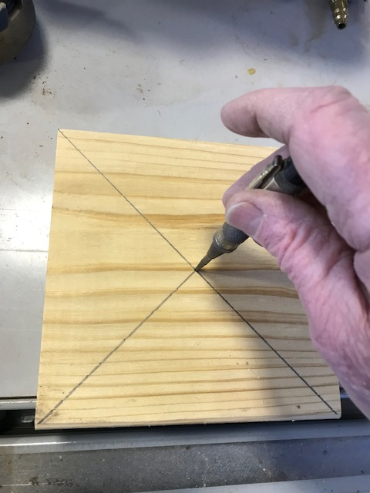
Using a Miter Saw, cut 2 opposite corners off.
Draw diagonals across cutoffs to find center and mark.
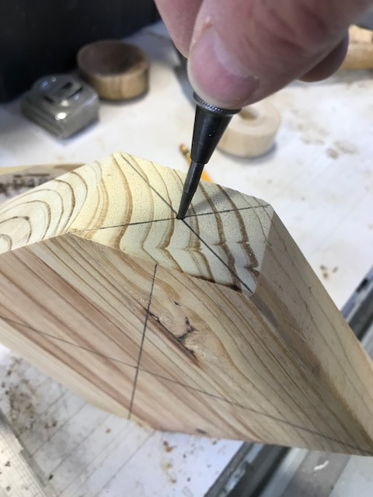
Mount on lathe between drive center and live center.
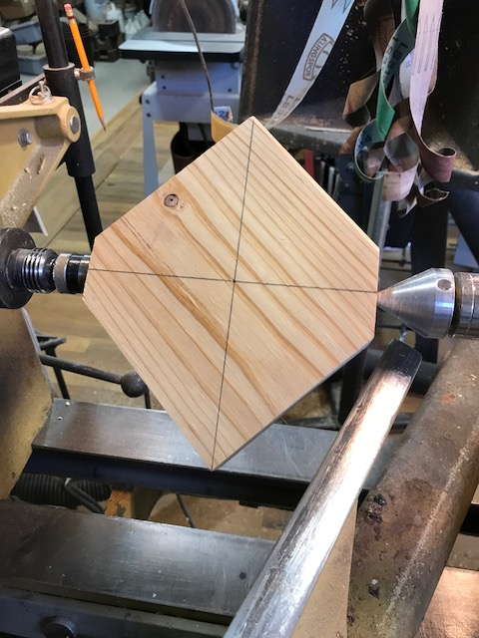
Turn a tenon approximately 2” diam.
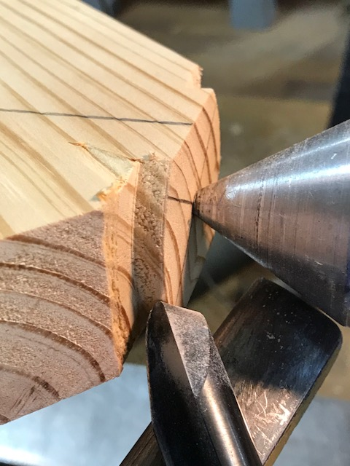
Mount tenon in chuck using live center to orient.
Drill hole in end to about 4” deep.
Using a bowl gouge, shape the neck to about 3/8” diam.
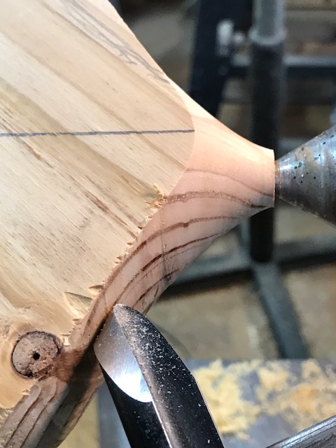
Using a bowl gouge, take very light cuts on the edge to shape the vase between the foot and neck. The foot should be about 3” long.
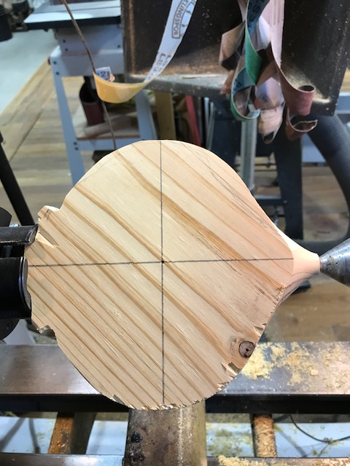
Using a vacuum chuck, align the shaped vase using the live center and the diagonal divot.
Using an aggressive detail spindle gouge, shape a gentle curve from the center to the foot & neck with a push cut. The edge of the cut should blend, not cut into the 3/8” neck.
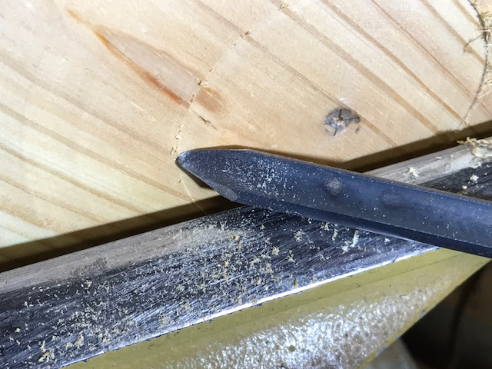
Mount the other side with the vacuum chuck using the live center and the diagonal divot.
Repeat the detail spindle cut above.
Sand to refine the curve of the vase and round the edges.
Saw off the foot.
Finished Thin Vase
