3 & 6 Pointed Vessels Emerging from a Cube Brian D. Schrader
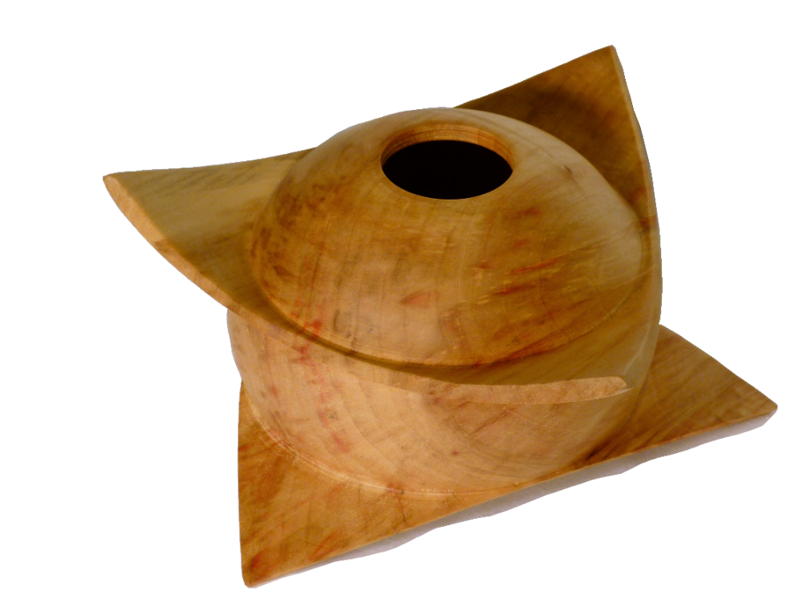
The shapes that might emerge from a cube are limited only by your imagination. These might be simple 3-pointed bowls, lidded boxes or more challenging 6-pointed hollow forms with finial lids.
Determine how large a cube you want:
How large a cube do I want? That depends on the desired end piece and the throw of your lathe. A small Christmas ornament can be turned between centers and can start with a small block. A bowl or hollow form will need to be mounted in a jaw chuck and will need a larger block. When the cube is placed on the lathe, the cube will rotate on an axis between opposite diagonal corners and the remaining 6 corners are going to swing a larger radius than the sides of the cube. This is an interesting characteristic of this style of turning that will be more evident in the demonstration, or when you try this in your own shop. I use a general 9/16 rule to evaluate the maximum cube that might be turned on a lathe. If you have a 16” throw on your lathe (8” radius between the axis and the ways of the lathe bed), then the general rule allows a cube to be nominally 9”. Keep in mind you also need space to position and move the banjo. The desired “points” that emerge from the cube are delicate and it can be disappointing to fracture a point when positioning the banjo.
Cut the cube to be square and even:
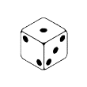
We need a block of wood that is a near perfect cube. The block can be trimmed with virtually any type of saw; band saw, table saw or a miter saw. The steps outlined here are based on the use of a band saw, but can be modified to accommodate the size block and equipment to be used. To trim your stock to a cube, first check the setup of your saw. If the blade is not perpendicular to the table, the faces of the cube will not be correct and your finished piece will be irregular. I rough cut a blank nominally ½” oversized size for the desired finished cube. I have found that I get best results when I think of the rough wood block as a common 6 faced die. With a smooth, straight stroke through the saw, cut face “1” of the cube, removing approximately ¼” of the oversize allowance. Using that cut face against the table, cut face “2” perpendicular to face “1”. Now keep face “1” against the table, and place face “2” against the miter guide, push the block through the saw to cut face “3”. If the saw blade, table and miter are set correctly, this will create faces “1”, “2” & “3” in the desired perpendicular relationship. Now set the rip fence to the desired finished cube dimension. Rotate and roll the rough shape so that one of the three reference faces “1”, “2” and “3”, is always against the table and one reference face is always against the rip fence. With 3 cuts, you will generate each of the remaining faces “4”, “5” & “6”. If the rip fence and miter guide are set correctly the opposite faces of the cubes will be parallel, adjacent faces will be perpendicular and the length all 8 edges will be identical.
Setup on the lathe:
Once the block is shaped to a cube, we are ready to go to the lathe. How do we chuck this odd shape? What chuck works best? For the initial attempts at this style of turning, I recommend turning between centers with no chucks at all. I remove the jaw chuck from the headstock and insert one corner of the cube into the hollow spindle as illustrated in Figure 1.

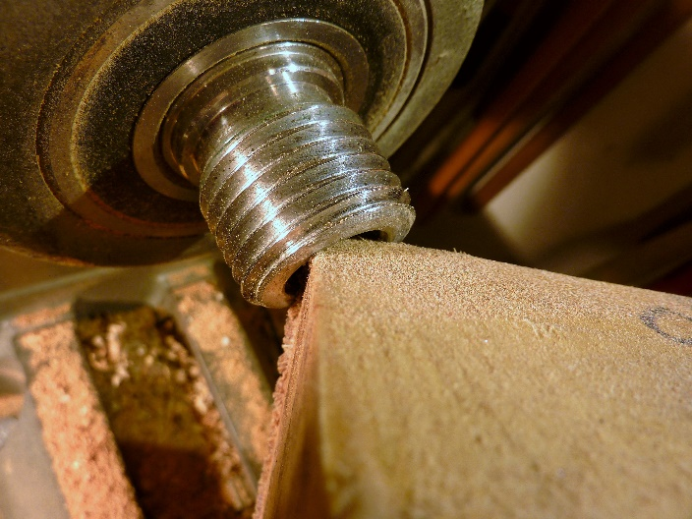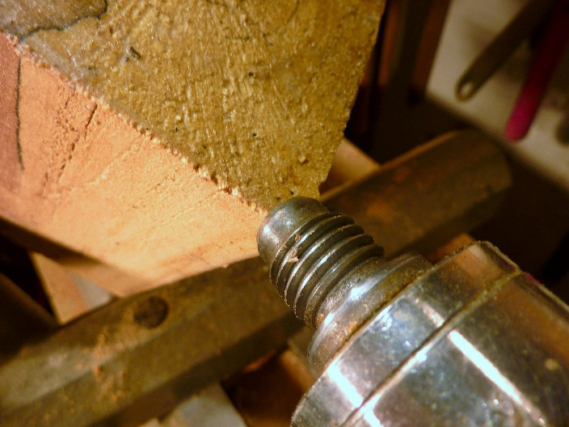
Figure 1: Corner inserted in Hollow Spindle Figure 2: Cube secured in Hollow One-Way live center

Bring the tail stock up to support the opposite corner in the hollow center of the One-Way live center as illustrated in Figure 2. (You may need to remove the pin from the live center.) Position the tool rest to check the sweep of the points during rotation. On the tool rest, mark the position of one point and determine if the other points repeat the position of the passing points. This is shown in Figure 3. If the points do not pass the marked position on the tool rest, try slightly shifting the corners inserted in the hollow bores of the head & tail stocks and repeat the alignment check. If after repeated attempts, the points do not align, check the squareness of the cube. Once the points repeat the location passing the tool rest as close as possible, tighten the tail stock and recheck the points passing the tool rest.

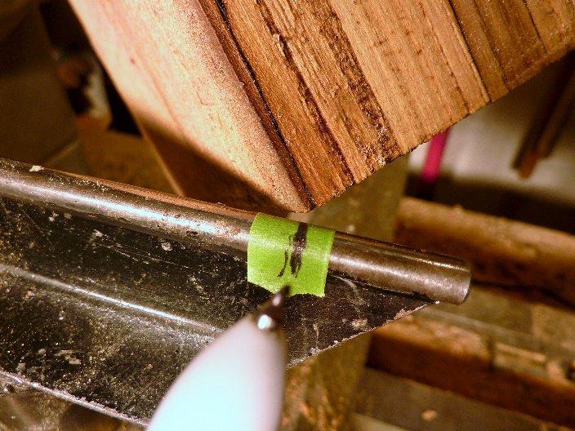
Figure 3: Mark the location where the cube corner swings past the tool rest

With the tail stock tight against the cube, there will be sufficient friction against the head stock to spin the block. This friction drive offers a nice anti-catch feature as any catch simply stops the rotation of the block. The initial turning is an intermittent cut and even small catches will tend to stop the rotation. If the gauge can’t be brought up to the block without stopping the rotation, tighten the tail stock to create more friction. Like all turning you will start the piece in a slow RPM and increase the speed. Unless the block was extremely non-uniform the center of mass of the cube will be on center and the block will rotate smoothly with virtually no vibration at moderately high speeds. Once you have some experience with the friction chuck, and you want to do more pointed shapes, a special chuck can be homemade or purchased. (Search ‘3 Point Chucky’ from Rubber Chucky Products, LLC.)
Shaping the vessel:
Now we are ready to start generating chips! Stand back and examine the ghost or phantom shapes as the cube rotates. Be aware of the rotating corners of the cube and always keep your tool rest out of the path, but more importantly always keep your hands on the operator side of the tool rest and avoid the temptation to place delicate flesh in the path of the cube. As the shape develops moving the banjo and tool rest will be a challenge to reduce the overhang and chatter on your cutting tools.
At some point you will need to cut a tennon and clamp the block in a jawed chuck. It might be surprising how far into the corner of the cube you must cut to develop a tennon to fit your jaws. You can start shaping the block in the friction drive set up, but don’t go too far without developing the tennon. It is disappointing to rough out your shape and prepare to cut the interior of the bowl or start hollowing, only to find the tennon you need encroaches on your form.
Once you have the tennon cut and the block mounted in the clamping jaws you are ready to start the shaping of the block. Mechanics of cutting the block and cutting the tennon have controlled the approach to this stage. Now imagination and creativity take control of the direction moving forward. The two primitive sketches below illustrate a simple 3-point bowl and a 6-point hollow form.

Illustration 1: Simple 3-pointed Bowl and a 6-pointed Hollow Form
There are many YouTube videos on ‘Bowl from Cube’ or ‘3-winged/Pointed Bowl’, etc. Most of the videos follow the very basic, 3-pointed bowl form illustrated in the sketch above using the natural shape of the cube and only round off the corners. Don’t stop there! Experiment!! Alter the profile of the sides. Try an Ogee shape allowing the points to roll out as petals of a flower blossom. With very little modification to the approach, the 3-pointed bowl can be turned into a lidded box with points.
For the more adventurous, try the 6-pointed vessel. The body of the vessel can be a bowl or a hollow form. With this style vessel three points sweep a plane and the remaining three points sweep a parallel plane. Depending on the angles you cut the gap between the two planes is some form of “V” or “U” shape. You potentially will have a long overhang on your gouge when trying to cut this area between the two planes. To reduce the vibration, you may need to use a larger gouge. You may need to reposition the banjo and the tool rest to get deeper into the “V”. Be aware at all times where the points are spinning and the limited work area available in the “V”. I have fractured points on the opposite side of the “V” from where I was cutting by encroaching on the free spinning points.
Regardless of whether making a 3- or 6-point vessel, at some stage you will need to remove the live center and hollow the bowl area or drill for a hollow form. While running the lathe always be aware of the spinning points and where you are placing tools and fingers. Always stop the lathe before repositioning the banjo. If you are turning a block that is near the throw of the lathe be aware of where the ‘down’ points might be. The points are delicate and it is extremely frustrating to fracture a point by impacting it when moving the banjo. (Voice of experience.)
Sanding and finishing:
Once the shape is complete you enter the realm of sanding. Again, be careful! Sanding many areas of these vessels is safest when performed with the lathe at the absolute slowest speed… STOPPED! When finished sanding, remove the vessel from the jaws, reverse chuck it with a jam chuck or vacuum chuck and turn away the tennon. Now apply a finish of your choice.
Don’t forget to sign and date the piece so your friends know you made this vessel and make them wonder how.

