Specifications from Beads of Courage
I am referencing the information from the Beads Of Courage website, information for woodturners.
http://www.beadsofcourage.org/pages/woodturners.html
All of the specifications are referencing internal dimensions. These are also the

Finishing
These are sick children! Make sure the finishes are safe. Walnut Oil, boiled linseed oil, and other similar finishes take a long time to completely outgas. These should be avoided.
It is also requested that painted finishes not be used. I presume this is to avoid paint chips that can find their way into bad places (mouths, cuts, incisions, etc.).

Boxes
The volume of these are easy to figure out. It is: VOLUME=WIDTH x LENGTH x HEIGHT (WxLxH). The minimum suggested size is 4"x6"x4" yielding a total volume of 96 in³

Cylinders
The guidelines from beads Of Courage suggest 6" (5" minimum) diameter and 5" (4" minimum) height. The formula for the volume of a cylinder is: VOLUME = RADIUSxRADIUSxPIxHEIGHT ($V=πr^{2}×H$ ). Radius is half of the diameter.
For the suggested 6"x5" cylinder the volume is: 3x3x3.14159x5 = 141 in³
and the minimum 5"x4" cylinder the volume is: 2.5x2.5x3.14159x4 = 78.5 in³

General Vessels
There are no real guidelines for the dimensions of and arbitrarily shaped vessel. It seems reasonably clear that the overall volume needs to be the guideline. There are several ways to estimate the volume.

Spherical Shapes
The formula for the volume of a true sphere is: $V=4/3×πr^{3}$ . For a 6" sphere the volume is:
4/3 x 3 x 3 x 3 x 3.14159 = 113 in³. A true sphere is not practical as an external shape, because it rolls, so a base is required (remember we are talking about internal dimensions).

Conical Shapes
The formula for the volume of a cone is: $πr^{2}×H/3$ . For a cone that is 8" in diameter and 9" tall the volume is: 4 x 4 x 3.14159 x 9/3 = 150 in³. However, this is the total volume. If you cut off the top 3" to be the lid it is reduced by the volume of that cone. The truncated cone (called a Frustum of a cone) is more complicated to calculate because it depends on the diameter of the cut off section. The calculation for this requires the bottom radius (R), the top radius (r), and the height (h). The formula is:
V= π x h/3 x (R² + Rr +r²). But we don't know r! So this is more complex. There are on line calculators for this.

Approximations are easier!
We are not trying to be mathematically correct, we are trying to hold beads! Take vessel and break it into sections that are close to cylinders. Calculate the volume of each section and add them up. This is especially easy for segmented vessels - calculate the volume of each ring.

If all else fails
Put rice in it. Dump it out and measure how much it is. 1 cup = 14.4375 in³ so you need 7 cups or more.

Methods of making vessels

Solid
Start with a section of tree caucus. Turn the inside and outside. Make a lid. Finish them both.

PVC Pipe
You can purchase a section of 6" PVC Sewer and Drain pipe. Lowes sells 2' lengths for about $15 and 10' lengths for $35. Use a cradle or other method to secure the pipe from rolling and cut 5"-6" sections with a hand saw, band saw, or other kind of saw. Turn a bottom and top to fit. Make a hole in the top and fit it with a lid. 2x8 construction lumber works well for this purpose.
The PVC pipe is not very attractive. Before assembly you can cover the pipe with paint, wall paper, contact paper, kid friendly fabric, or whatever strikes your fancy. There is a kid out there that will like whatever you make! Make sure that you use a glue that will keep the covering in place.

Staved with straight sides

Beveled Edges
This is like a very tall single segment ring. Construction and calculations are the same, only the height of the piece is different. Think of a column with a hollow center. The length of the stave is the total vessel height. The bevel angle and width of the piece are calculated the same was as for a segmented pieces EXCEPT the angle is used to set the bevel of the saw. You can also use a router to cut the angle - if you can find the right bit. Many manufacturers sell bevel (chamfer) bits for 4 sided (45ᵒ) and 8 sided (22.5ᵒ). 15ᵒ (12 sided) and 30ᵒ are also available.

Multi-Sided Glue Joint (a.k.a. Birds mouth joint)
This is a stave cut on the edge with special type of router bit joint. One source is MLCS. They have single bits or a set of 3. They are:
#7638 6 or 12 sides
#7639 8 sides
#7640 16 sides
#1452 set of all three
The advantages to this type of construction is that the router bit takes care of the angle, the joints are self-aligning, and you only have to rout a single side of the stave.

Compound Angle Staves
This a vessel with straight, sloped sides. The effect is similar to a pyramid with more sides. It is similar to the straight sided vessel in construction but adds complexity. There are multiple angles to compute. Accuracy is critical in all cutting. Clamping for assembly is rather interesting. Calculations are below. It is probably best to look them up!

Segmented Vessel Calculations
All of the calculations are fairly easy with a calculator that has trigonometry functions (sin, cos, tan).
In the formulas below:
N= Number of Segments
D= Outside DIAMETER of the ring
R = Outside RADIUS of the ring
r = Inside Diameter of the segment
L = Outside segment length (Major Cord)
l = Inside segment length (Minor Cord)
Θ = Miter Angle (angle of the segment cut for symmetrical segments)
S= Slope of a compound Stave vessel

Segment Dimensions For Flat Rings
Miter angle (Θ) = $360÷(2N)$ Setting for fence angle
Segment Length (L) = $\tan{(Θ)}×D$ Outside measurement to cut segments

Total angle = $360÷N$ for completeness - you don't need this
Interior Length (l) = $2×r×\sin{(Θ})$ for completeness - you don't need this

Straight Stave Construction
Bevel angle (Θ) = $360÷2N$ Setting for blade angle
Segment Length Vessel Height

Compound Angle Stave Construction
Miter angle (Θ) =$\tan^{-1}\left(1÷\left[\cos{S×\tan\left\{360÷2N\right\}}\right]\right)$ Setting for fence angle
Blade angle(BA) =$\tan^{-1}\left(\cos{Θ}×\tan{S}\right)$ Setting angle for blade

Building the Segmented vessel

Design the shape
The starting point is to determine what you want the final project to look like. Try sketching the shape from the centerline only to one side, and use a mirror to see the final shape. You could also try the "bead chain" method. However you come up with it, you will need the profile and wall thickness of the final piece.

Decide on the Number of segments
The number of segments is needed to determine all of the parameters of the pieces to be cut. The fewer the segments the less joint cutting error is multiplied. Low segment counts yield higher waste - think of turning a circle from a four sided glue-up.

Determine the wood
You can make pieces for a single type of wood, different woods for each layer, different woods within a layer, etc. The possibilities are unlimited. You need a plan or "map" of the wood(s) for each ring.

Prepare the base
I prefer to use a solid wood base. Segmented bases have a higher likelihood of failure due to differential expansion and pressure stresses that can crack the joints or the wood. Mount the base on a faceplate to turn a recess (or tenon) for mounting on a chuck. You can also just use a faceplate and waste block.
Turn and finish the face. Now is the best time to put whatever curvature you want in the base. Leave the rim extra thick.
Flatten the rim with a gouge or scraper. Then use a sanding board to make sure it is completely flat. Put pencil marks on the rim to make sure none has been missed.

Calculate the segment piece parameters
Find or figure out the thickness of the segment strips. There are a lot of ways to do this: graphical, imperial, calculations, software generation, guess, try and hope, etc. Use the method that works for you. I usually leave extra thickness inside and outside to allow for "on the fly" design changes.

Figure out and cut the required strips
From all of the above you can determine how much of each wood you need. Make sure to cut some extra to allow for the saw kerfs per segment. Also make each strip long enough so you still have a handle to hold against the fence and be safe. I will fiddle with the design to make as many strips the same width as is reasonable. It cuts down on mistakes and waste.
The design will drive the type of cutting required. If you are trying to get the best grain match you will need more length to account for the additional waste. Highly figured woods seem to require this. If you are mixing woods or not trying to match grain you can use the economy cutting methods.
Cut each strip to length and rip it to width. If you have a number that are the same width you can use longer boards. I usually do all of the rip cuts as once. this helps avoid extra blade changes.

Assemble the rings!

Cut the segments
Mark the top and one edge of the strip (you will need this during assembly). Cut the number of segments required using a sharp, clean, smooth cutting blade. I usually cut the segments for a single ring and dry clamp to see if there are errors. Make sure to number the segments as you cut them, if you are doing grain matching. I usually do this as a matter of course. Put the ring segments in a numbered container or bag.

Sand the segments
A quick rub on some 80 grit will knock off the fuzziness left by the saw blade. Many segment turners construct a jig to sand the segments to length as well. This can also establish square faces on the pieces and a better glue joint.

Dry clamp
This is the best time to check for problems. you can "clamp" with a rubber band, band clamp, painters tape, stretch tape, etc. Do what works. Check to make sure all joints are tight.

Glue the ring
I use Titebond original wood glue. It gives me enough open time but sets quickly. Use plenty of glue since this is end-grain to end-grain. This really sucks up the glue.
If you noticed errors in the dry clamp up, or are unsure, glue up the ring is two halves by leaving the center line un-glued. This way you can get all of the segments glued in to half-circles, then sand the ends to a perfect fit.
I use High Pressure band clamps (a.k.a hose clamps) for my glue-ups. I find these to be easiest for me. Many turners use rubber bands (several) or stretch tape. These also work. The requirement is to get adequate pressure for the joints to not fail.
After the ring is in the clamps apply medium pressure to make sure it holds together but not to set the glue. Put a flattening circle on the top and bottom and clamp the sandwich. Loosen the band clamp and tighten the flattening clamps. Tighten the band clamp. Loosen and remove the flattening circles. Tighten the band clamp.
Doing things this way I find that I can glue up a lot of rings fairly quickly. Make sure to clean of the excess glue from the flattening circles before it sets.

Repeat the ring assembly steps
Repeat all of the above steps until the rings are completed. Allow the glue to dry. I usually wait overnight.

Flatten the rings
It is faster to sand them all at once if you can. You can also do one ring at a time for
You should only flatten one side of the rings if you are using a sanding board, a disk sander or belt sander. If you have a thickness sander, you should do both sides.

Assemble The Vessel

Glue a ring
You need to put the ring on well centered. I use the lathe and a centering cone. You can also mark the rings, measure and put on temporary alignment pieces, use a Longford chuck, use a stomper fixture, or many other methods. The better centered the ring is the less the waste. For some designs alignment is critical to the aesthetics of the piece.
Once the ring is centered it can be removed and glue applied. You need enough glue to make the joint but don't want to make a mess. Re-center the ring and apply clamping pressure. Again there are many methods. I use small bar clamps after the tailstock pressure. Try and remove excess glue.
Let the ring dry. Since this is long-grain to long-grain I find a couple of hours is sufficient. If you can wait over night the glue will be firmly set

Turn the ring
This is the easiest time to clean up the inside of the ring. It is the most favorable angle for a bowl gouge as the wall is low. Turn the inside round and to shape.
I find it best to blend the current ring to the prior ring (or base) at this time. It is one reason I prefer to glue one ring at a time. As I build the piece I will rough shape the outside as well. Wall thickness is easiest to measure now. I only turn to final wall thickness the ring below the current one. This leave maximum glue surface and accommodation for the following ring.

Flatten the ring
Use a gouge or scraper to get the ring close to flat. Apply pencil marks to the surface and sand with a flattening board until they are gone.

Repeat the Ring Gluing Steps
Repeat the above until the vessel is complete. Finish turn and sand the outside shape of the vessel frequently checking wall thickness. Turn the rim and provide for the lid.

Finish
Final sand and finish the vessel. Make sure to use an appropriate finish.
Turn a lid. Finish it and add decorations to the project as desired.

References, Links, Etc.

Products

Clamps
- NORMA GROUP/BREEZE HP4 4-6-1/8 SS Clamp
- Breeze HP-5 Extended Range Hi-Torque Clamp Effective Diameter Range: 6-1/8" - 9-1/8" (156mm - 232mm)

Videos and books
YouTube:
- Jerry Bennett's videos on Segmentology - These are some of the best explanations about segmented construction.
- Lloyd Jhonson's videos on Segment Pro and Segment Stomper
Videos:
- Curt Theobald
- Malcom Tibbets
Books:
- "Woodturning with Ray Allen" Dale Nish
- "The Art of Segmented Wood Turning" Malcolm Tibbetts
- "Polychromatic Assembly for Woodturning" Emmet E. Brown & Cyril Brown
- "Segmented Turning A Complete Guide" Ron Hampton
- "Segmented Wood Turning" William Smith
- "Segmented Turning" Dennis Keeling

Jigs, Gages, Fixtures
- Longworth Chuck Plans on the internet. Self centering chuck.

Websites

segmented woodturners.org
AAW group dedicated to segmented work

www.woodturnerpro.com
Software and some jigs/fixtures. Lloyd has been around segmented turning for many years and is a really nice guy. He usually has a booth at AAW and SWAT.

- This is the software I use - 3d Design Pro, Woodturner Pro, Lamination Pro:
- Shape design https://woodturnerpro.com/software/3ddesignpro.htm
- Segment Plan https://woodturnerpro.com/software/woodturnerpro.htm
- Feature Rings https://woodturnerpro.com/software/lampro.htm

There is a new application that Lloyd offers which is an all in one application
- Segment Pro https://woodturnerpro.com/software/segmentpro.htm

Lloyd aslo offers "The Stomper" Jig
- Woodturner Pro Stomper: woodturnerpro.com/hardware/stomper/index.htm

www.segeasy.com
Home of "The Wedgie" and "Seg-Easy" plates. This is where I got mine.
- Wedgies for Closed Segments for rings from 9 - 288 segments
- Wedgies for Open Segments for a wide variety of segments and gaps
- Segeasy plates Closed Segments for 10 different configurations
- Segeasy plates Open Segments for 12 different configurations
Several very good videos (also on YouTube) on the process. This website features Jerry Bennett's work and has videos from him.

www.MLCSwoodworking.com
Bevel and birds-mouth router bits (and lots of other stuff). Note that their router bits are not the highest quality, but they get the job done. They are a sister company of Penn State Industries (they are in the same building and showroom).

www.turnedwood.com
Excellent resource for segmented turning. He is also a very accomplished woodturner. Highly recommended!
- Offers the Segmented Ring Maker App which calculates a host of features for doing segmenting. It can calculate:
  - Flat Closed Frames (rings)
  - Open Segment Rings
  - Compound Rings
  - Staves
  - It can has options for: inches or mm, decimals or fractions, rounding tolerance, etc.
  - Versions available for phones, tablets, Windows PC, MAC
- Offers templates for a No Math method of doing designs (attached with permission from Kevin)
- Has designs for Flat and Compound miter sleds (samples attached with permission from Kevin)

www.segmentedturning.com
Another project planning program. This has a great many features and functions and is frequently updated. You can download a free 30 day trial.

www.marleyturned.com
A general woodturning site. The main attraction is the Online Tools tab. This is an online project planner and calculator. There is no cost to use it. As it says "These Utilities are free, and worth every penny... Use at your own risk.

http://www.advancedlathetools.com/
This is the supplier of the centering cones (frustum conical sections) I use. They have many other interesting products as well.
The Sanding Glove (www.thesandingglove.com) is where I purchased my set. Advanced Lathe Tools is the manufacturer.

Attachments courtesy of Kevin Neelley
www.turnedwood.com

Miter Sled
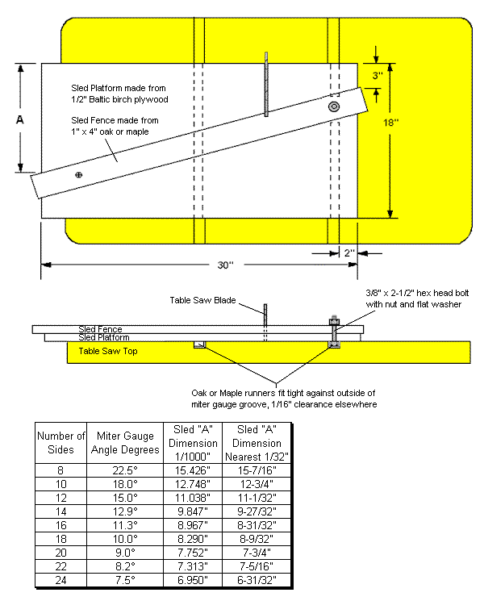

Compound Miter Sled
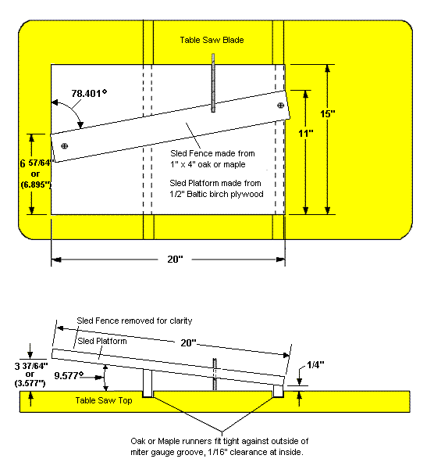

No Math Method Sample sheets
