Scab Bowls
By
Paul Coppinger

Introduction
Woodturners love to turn burlwood because of its beautiful grain. Unfortunately burls can be very expensive. An alternative is utilizing tree scabs which occur when a tree loses a limb and then grows a scab over the wound to seal and protect.
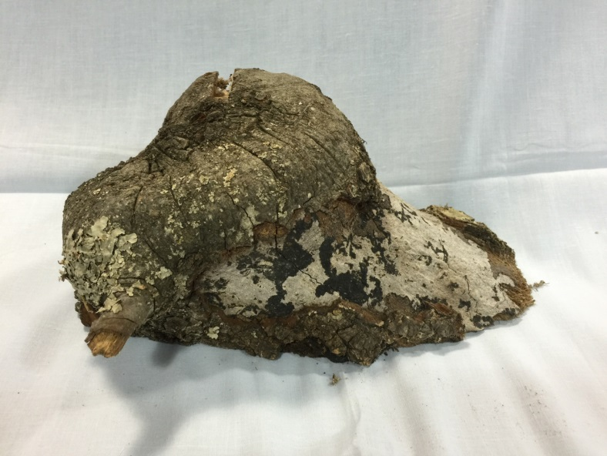
Fig 1 Oak Scab
Tree scabs may be used to turn very unique bowls.
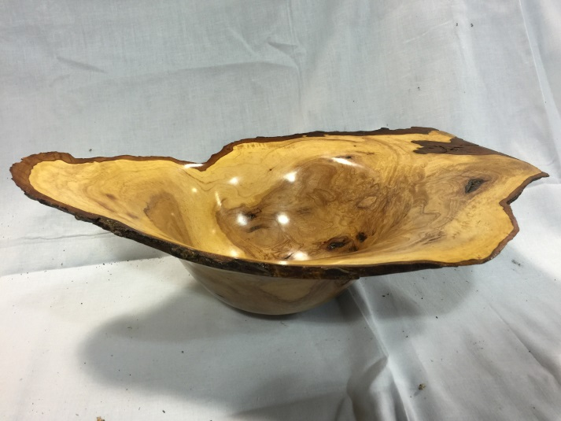
Fig 2 Finished Pecan Scab Bowl

Some scabs can be solid or may have partial remains of the missing limb.
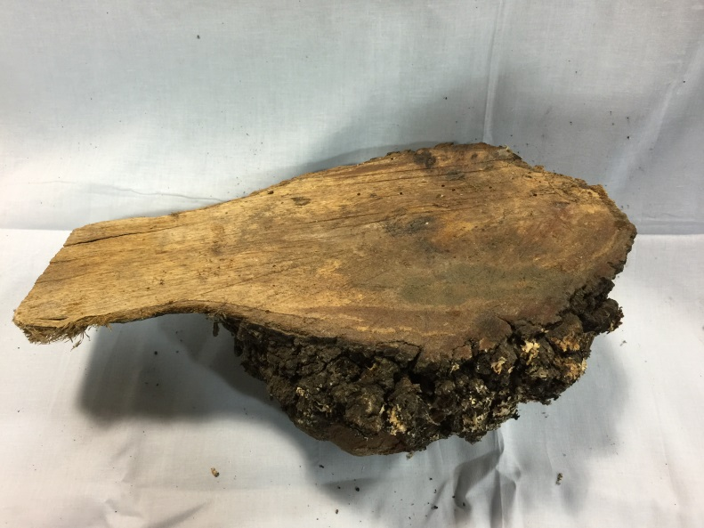
Fig 3 Scab with solid inner surface
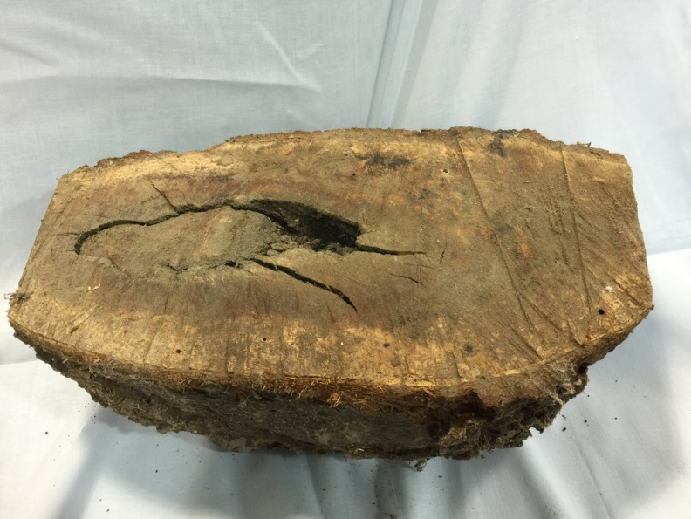
Fig 4 Scab with partial limb visible on inner surface
This determines the technique used to mount the scab. If the inner surface is solid, either a worm screw (screw drive) or a face place can be used to mount the scab to the lathe. (See Steps 1 & 2 below.)
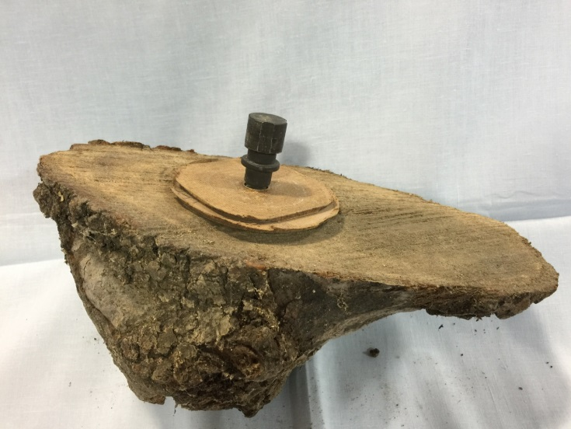
Fig 5 Scab with Worm Screw and Spacers
If the inner surface has voids from a partial limb, then a face plate is necessary. If the voids are larger than the face plate, then attach a large diameter waste block to the face plate. (See Steps 1 & 2 below.)
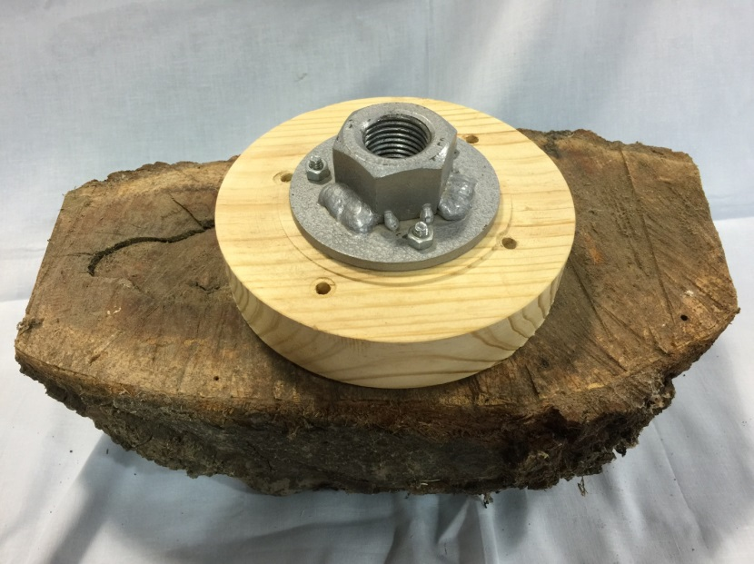
Fig 6 Scab with Face Plate utilizing large diameter Waste Block
The flat inner surface will be the top of the bowl and the “hump” will be the back of the bowl. After mounting on the lathe, the “hump” will be turned and shaped first, and then the scab will be turned around to actually shape the top of the bowl. Before beginning to turn, decide the technique to be used to mount the backside. A tenon may be turned on the backside so chuck jaws can compress when ready to turn and mount. Usually, the tenon diameter should be just slightly larger than the minimum jaw diameter for maximum strength. If the grain of the tenon is not end grain, increasing the diameter of the tenon will minimize the possibility of the tenon splitting off. Remember that tenons require a very square or slightly undercut inside corner.
A recession or hole may be cut so that when ready to turn and mount the scab, chuck jaws can reach into, expand and hold. The hole should be slightly larger than the minimum outside diameter of the jaws. The depth of the hole should be 1/8” minimum and the wall should be square or slightly undercut to the bottom of the hole.
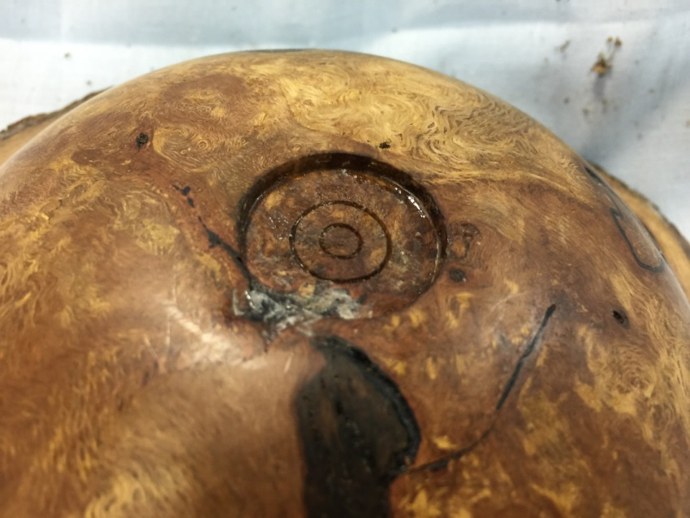
Fig 7 Backside Recession
Procedure
- Use a nail or any sharp-pointed object to find an approximate balance point on the inner surface. Compare the balance point with the general shape of the backside to attempt to center the backside “hump” to the spindle axis. Adjust as necessary.
- Worm screw: Drill hole approximately ½” deep. The drill diameter should equal the shank diameter of the worm screw. For Oneway screw drives, use 3/8”.
Face Plate: Position the face plate like the worm drive hole above. Next use woodscrews to attach the waste block to the scab being sure that the length of the screw will not affect the backside shape. Use at least 3 woodscrews to prevent “rocking” since the inner surface is seldom flat.
- Mount to lathe, turn down speed to minimum, wear impact face shield, step to side of scab and turn on lathe. Loose dirt and/or bark may fly off. Increase lathe speed until vibrations become excessive.
- Begin shaping backside using a 45-45-45 or 3-45 pull cut. (Adjust tool rest to ~ 45 degrees to the lathe, lower bowl gouge handle to ~ 45 degrees and rotate flute to ~ 45 degrees….3-45s.) All these are starting points to a pull cut from the “hump” to the edge. Shape backside to desired form.
- Either shape tenon or form recession.
- Sand entire backside and apply any embellishments.
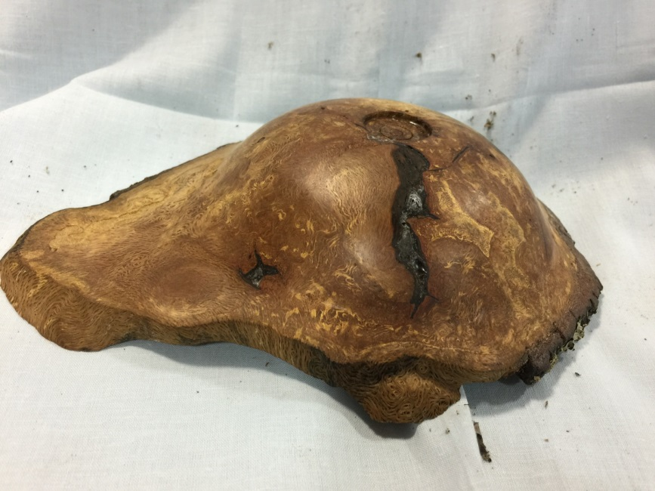
Fig 8 Completed Backside

- Turn and mount using the tenon or recession. (Oneway Talon and Stonghold chucks tend to loosen in the expansion mode so stop and readjust jaws to insure a tight fit in the recession.)
- Hollow bowl to desired shape.
- Sand top of bowl.
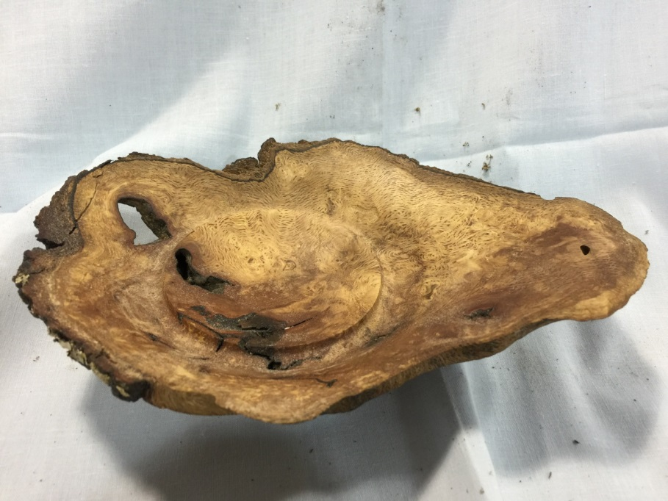
Fig 9 Scab Bowl Completed

The next time you are cutting down a tree or processing a log or just happen to be walking through the woods with your chainsaw and see a scab, take a moment to cut it off … then go back to your shop and turn your first scab bowl.

